COTSWOLDS LEADER PROGRAMME UPDATE

Summary: To present an update on the progress of the LEADER Programme.

Recommendation: That the update report be noted.

Officer Ref: James Webb, LEADER Programme Manager (01451 862033)

General Items

- Programme timing
In August we requested a four month extension to the end of the programme from 29/03/2019 to 30/07/2019. This request was approved by the Rural Payments Agency in October. All grant claims must be paid by 31 December 2020.

- Programme performance
The programme has supported 32 projects (closed & contracted) with a total value of £998,765, which represents 55.5% of the allocation. Collectively this investment has created 45.57 new jobs. On 28/11/2018 the LAG approved four applications (x2 Farming & x2 Business) with a collective value of £111,190. These applications will be contracted over the next two weeks. On current projections, the programme should have contracted £1.4million by the end of March 2019 and be fully spent up by end of July 2019.

- Programme staff
Lioba Erwert started on Monday 15th November as Programme Administrator and is settling in really well. Mandy Pressland has been promoted to Office Manager, which will include some input into the LEADER programme.

- Projects

Closed Projects: completed projects with grant paid in full

Priority 1 – Support to increase farm productivity
£10,059 towards a Cluster Flush system for a dairy farm in Gloucestershire.
£5,206 towards a Mobile Sheep Handling system for a sheep farm in Worcestershire.
£49,958 grant towards a Robotic Milking system for a dairy farm in Wiltshire.
£20,414 towards a Cluster Flush and EID Rumination Collars for a dairy farm in Gloucestershire.
£26,061 towards a Trailing Shoe Slurry System for a dairy farm in Gloucestershire.
£17,435 towards a Trailing Shoe and Rumination collars for a dairy farm in Wiltshire.
£20,048 towards a Cluster Flush system and Cow Mattresses for a dairy farm in Wiltshire.
£6,247 towards a Fertiliser Spreader with GPS for a farm in Gloucestershire.
£9,798 towards a Cluster Flush for a dairy farm in Gloucestershire.
£29,757 towards a Weaving Drill for an arable farm in Oxfordshire.
£23,371 towards an ice-cream and butter production facility on a dairy farm in Gloucestershire.
£40,838 towards a System Cameleon Drill for an organic arable farm in Gloucestershire.
Priority 2 – Support for micro and small businesses and farm diversification
£40,000 towards the construction of 10 new high quality office units: Westend Office Suites.
£13,011 towards the fit out of a business unit and associated equipment: Saltpig.
£48,849 towards the construction of a new farm shop and café: Vegetable Matters.
£47,899 towards building work to double the retail space at Wotton Farm Shop.
£10,462 towards new equipment and electric supply: Capreolus Distillery.
Priority 3 – Support for rural tourism
£29,292 towards improved access and two wooden holiday homes: Longhills Farm Kennels.
£16,075 towards a Roundhouse and associated facilities for a tourism provider in Wiltshire.
Priority 6 – Support for increasing forestry productivity
£10,000 towards a firewood processor and Log Deck: Little Owl Logs
£49,737 towards a large firewood processor for a business in Gloucestershire.
£38,112 towards Forestry equipment and a Firewood processor for an Estate in Gloucestershire.

Contracted Projects: projects that haven’t yet claimed or *claim received and being processed

 | Priority 1 – Support to increase farm productivity
* | £6,991 towards a fixed Cattle Handling System for a farm in Gloucestershire.
 | £5,098 towards a Mobile Sheep Handling system for a sheep farm in Gloucestershire.
 | £37,720 towards a Horsch Sprinter 6ST Drill for an arable farm in Gloucestershire.
* | £31,385 towards a Weaving Drill and steering system for an arable farm in Gloucestershire.
 | Priority 2 – Support for micro and small businesses and farm diversification
 | £17,891.38 towards specialist particle analysing equipment for a business in Gloucestershire
 | £99,982 towards a Food & Farming Education Centre in Oxfordshire: Cotswold Seeds.
 | £99,995 towards converting an old building to create new offices for a business in Wiltshire.
 | £38,440 towards a log drying kiln and tipper delivery truck for a business in Gloucestershire.
 | Priority 3 – Support for rural tourism
 | £49,993 towards the construction of 5 residential holiday units in Gloucestershire.
 | Priority 6 – Support for increasing forestry productivity
* | £48,642 towards storage for woodchip and a Firewood processer for a business in Oxfordshire.

As the programme matures, we are seeing more projects completing and submitting their claims. Some of the programmes largest projects are currently under construction. Here are some recent examples:

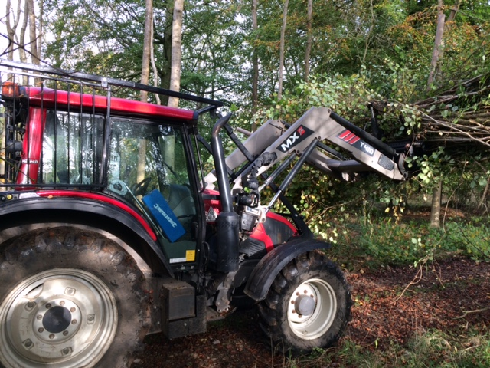  Photo: Forestry tractor with guarding (19th October) | Bathurst Estate (Earl’s Fund), Gloucestershire  £38,112 grant towards Forestry equipment and a Firewood processor.  At the time of the visit, the foresters were ride widening, which increases the life of the forest track and is very beneficial to wildlife. Sunny rides are well known to benefit a suite of woodland species.

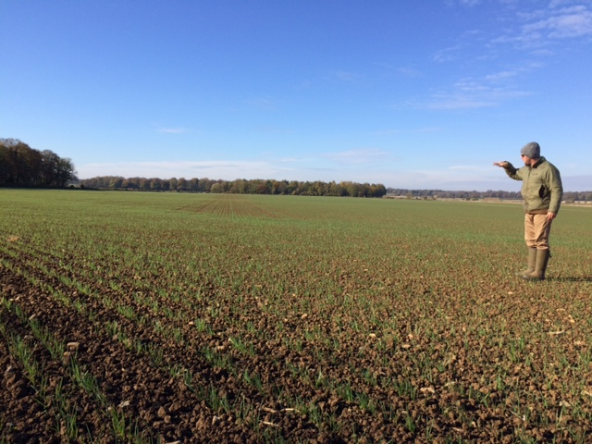  Photo: Establishment of winter oats following direct drilling (31st October) | Cotswold Organic Growers  £40,838 towards a System Cameleon Drill for an organic arable farm in Gloucestershire.  Direct drilling reduces establishment costs and energy inputs and also beneficial for soil health & structure, erosion and run-off / leaching.

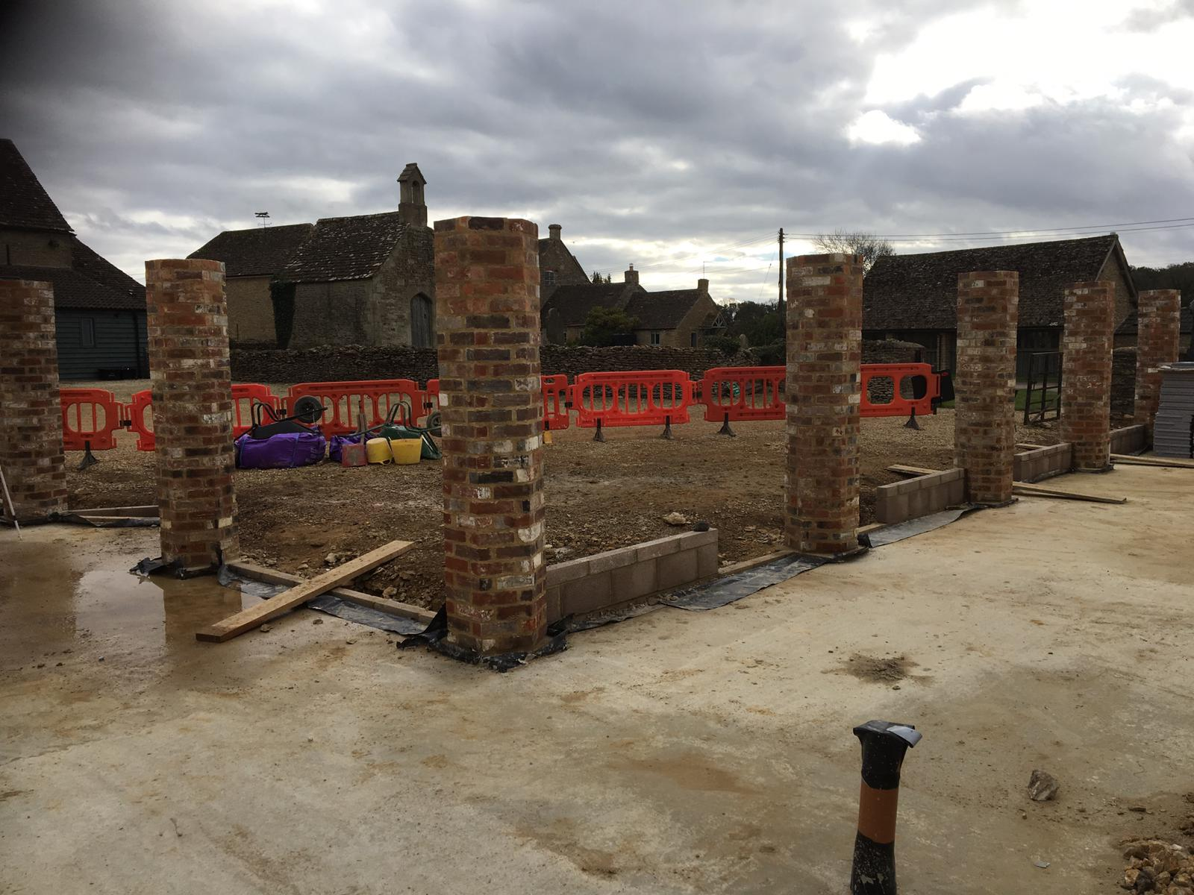  Photo: Rebuilt columns with concrete floor (3rd November) | Veritas Property Management, Malmesbury, Wiltshire  £99,995 towards the conversion of an old agricultural building to create new office space to facilitate business expansion. The new office space is adjacent to the existing HQ and will allow this successful business to expand its team. This investment will ultimately result in the creation of 14 new jobs.

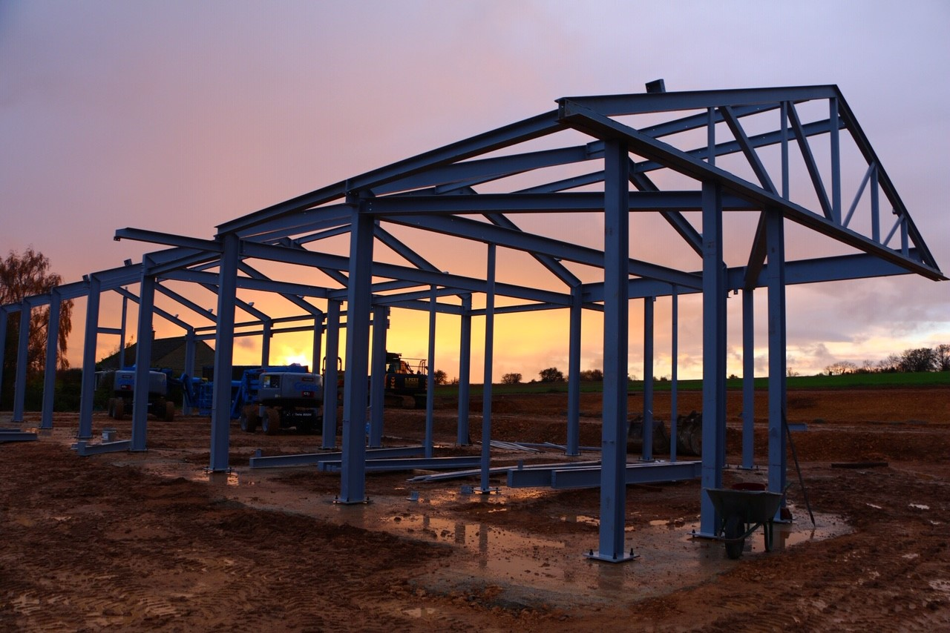  Photo: Education Centre steel frame going up (7th November) | Cotswold Seeds, Moreton-in-Marsh, Gloucestershire.  £99,982 grant towards Honeydale Farm: an Education Centre for Diverse Farming in west Oxfordshire. It will promote diverse farming, which utilises many different crops in rotation along with livestock, grassland, woodland and water and aims to increase soil fertility and create a self-sufficient and regenerative farming system.

Supporting Papers:

Appendix A - Targets vs Actuals

