**COTSWOLDS CONSERVATION BOARD BUSINESS PLAN 2019 – 2022**

1. **The Cotswolds Conservation Board**

Established by Parliament in 2004 the Cotswolds Conservation Board (The Board) has two statutory purposes:

* to conserve and enhance the natural beauty of the AONB
* to increase understanding and enjoyment of the special qualities of the AONB.

In fulfilling these purposes, the Board has a duty to seek to foster the economic and social well-being of local communities within the AONB.

The Board has four ambitions which serve as key developmental priorities, they are:

* Promotion of the Cotswolds as the Walking and Exploring Capital of England.
* The local design and delivery of a Cotswolds package of agri-environment payments for public goods and services and rural development support.
* Ensuring communities and businesses within and around the AONB identify and celebrate being part of a nationally recognised landscape.
* To promote the case for the Cotswolds being designated as England’s next National Park.

**2. Summary Work Programme 2019-2022**

This programme converts the outcomes and policies of the AONB Management Plan[1] and its operating context[2] into actions for the Board, it is arranged under the Management Plan’s outcomes and policies.

The figures refer to the budget allocated to each Management Plan outcome for 2019/20, including staff time and on-costs. The % figures refer to the 3 years of this plan. This expenditure also reflects any income earned under these headings.

The initials refer to the lead officer, Board member and any task and finish or working groups which have been allocated to actions and they are listed in that order. The allocated Board member is the champion within the Board for that area of work. Names are given at the end of the work programme.

Progress against all work is reported to the Executive Committee which also takes a direct interest in work not covered by another group

**CROSS CUTTING (CC)**

**Outcome 1: Working Together £106,167 8%**

**CC1: Developing a Consistent, Coordinated and Landscape-led Approach across The Cotswolds AONB:**

* Re-inforce the Cotswolds as a single entityby bringing agencies together to consider the Management Plan, and in 2021/22 start the development of the 2024/29 **Management Plan**. ML EE.
* Seek to influence the work of others through the publication of position statements, guidance, reports, updates and other **publications**. AH
* Seek opportunities to collaborate in advancing **research** in accordance with the Board’s research agenda. ML
* Promote the case for the Cotswolds being designated as a **National Park**. ML EE.

**CC2: Compliance with Section 85 of the Countryside and Rights Of Way Act (The ‘Duty of Regard’)**

* Monitor **Section 85** of the Countryside & Rights of Way Act compliance and develop agreed protocols with public bodies. JM GL.

**CC3: Working In Partnership**

* Lead and participate in **partnerships** and manage our **changing relationships** with local authorities, agencies and NGO’s. ML.
* Work with businesses through projects such as the Cotswolds **LEADER** programme and **Cotswolds Choice**. JW/SS PC or SK. LLAG.
* Encourage communities and businesses to value and celebrate being within the AONB by maintaining the AONB **boundary markers** and investigating the inclusion of AONB branding on village and town place name signs. JM. TM.

**Outcome 2: Natural and Cultural Capital and Ecosystem Services £17,536 2%**

**CC4: Natural and Cultural Capital and Ecosystem Services - Principles**

* Develop our understanding of the full range of benefits that the **natural capital** of the Cotswolds AONB provides to society and business & place a value on them. MC/ML. TM.
* Develop the overarching concept of **cultural capital** as applied to the Cotswolds and develop our understanding of the cultural assets and their value. MC.GL.

**Outcome 3: Climate Change £8,692 1%**

**CC7: Climate Change Mitigation**

* Monitor and disseminate the results of the Climate Change Adaptation and Mitigation **Demonstration Project.** JM.

**CC8: Climate Change Adaptation**

* Review the Cotswolds **Climate Change Strategy.** MC. EMS or JF.

**CONSERVING AND ENHANCING (CE)**

**Outcome 4: Landscape and geology £121,909 13%**

**CE1: Landscape**

* Attempt to reduce the impact of **electricity pylons.** SS/JM
* Shape a 25 year vision for the Cotswolds landscape by engaging communities, the academic sector and other stakeholders in a **Future Landscapes Programme.** MC EMS.
* Deliver a **rural skills** training programme and develop associated programmes for young people including apprenticeships. EB CLGM. RSTFG.

**CE2: Geology**

* Reinforce the value of the AONB through its **geological resource** (year 2). MC. JB.
* Develop a Heritage Lottery Fund proposal engaging people in exploring and managing a characteristic suite of heritage assets associated with **Cotswolds stone**. SS DT. EFWG.

**Outcome 5: Local Distinctiveness £8,589 1%**

**CE3: Local: Distinctiveness**

* Describe and illustrate features that are characteristic and **distinctive** of the Cotswolds. Publish a single **building design guide** for the whole Cotswolds AONB (year 2). JM NH.

**Outcome 6: Tranquility £2,318 0%**

**CE4: Tranquility**

* Champion the value of the AONB through its **tranquility.** JM GK.

**Outcome 7: Dark Skies £1,738 0%**

**CE5: Dark Skies**

* Pursue **dark sky reserve status** (pending Board decision in December 2018). MC GL. DSTFG.

**Outcome 8: Historic Environment and Cultural Heritage £17,861 2%**

**CE6: Historic Environment and Cultural Heritage**

* Work with Historic England and the County Councils to monitor and manage **scheduled monuments.** RJ DT.

**Outcome 9: Biodiversity £129,078 13%**

**CE7: Biodiversity**

* Seek to increase the amount of appropriate **coppicing and woodland management** within the AONB. MC/SS HA.
* Deliver the **Glorious Grasslands** project to enhance the AONB's natural grassland network including road verges. MC NB.
* Support the development of the **Treescapes**: Arising from the Ashes programme. MC RC. EFWG.
* Support landscape scale conservation through the Cotswolds **Ecological Networks** Forum and the two Cotswolds Nature Improvement Areas. SS MtD.

**Outcome 10: Rural land management £31,028 3%**

**CE8: Rural Land management**

* Engage with **land managers** to deliver the Board's purposes through the farming forum and the farming, forestry and equine study. MC. NB
* Improve the landscape setting of Bath by supporting the ‘**BATHSCAPE**’ programme. MC MV.
* Develop a new HLF proposal focusing on the **Evenlode** catchment. SS NC/TM EFWG.
* Respond to consultations on **land management proposals** Inc. woodland & Natural Flood Management. MC BMC.
* Develop a proposal for a post-Brexit **agri-environment** & rural development scheme that will enhance the Cotswolds. MC NC.

**Outcome 11: Development and Transport £56,193 6%**

**CE10: Development and Transport**

* Influence significant **planning and transport proposals** seeking to ensure that development is compatible with the purpose of the AONB designation in line with the AONB Management Plan and associated documents. JM MMC. PIWG.
* Influence **strategic planning** at all levels e.g. Sub regional, Unitary, District and Neighborhood plans. JM MV. PIWG.

**CE11: Major Development**

* Respond to major development proposals including **railway electrification** and the **A417** ‘missing link’. ML. JM. PIWG. A417TFG.

**INCREASING UNDERSTANDING AND ENJOYMENT (UE)**

**Outcome 12: Sustainable Tourism £35,746 4%**

**UE1: Sustainable Tourism**

* Grow **Caring for the Cotswolds**, the Cotswolds Visitor Giving Scheme, enabling visitors and the tourism industry to reinvest in the AONB’s landscapes. AH DS. CfCTFG
* Make the Cotswolds the best landscape for the visitor to explore by **public transport** by publishing and promoting the Explore the Cotswolds by Public Transport guide and supporting the associated Cotswolds Discoverer bus/rail ticket scheme. AH BMC. WEWG.

**Outcome 13: Access and Recreation £255,299 29%**

**UE2: Access and Recreation**

* Maintain the **Cotswold Way** to National Trail Quality Standards. RJ. WEWG.
* Monitor and help maintain **named routes** and the wider **public rights of way** network. RJ BMC. WEWG.
* Promote and help deliver a **guided walks** and events programme and broaden participation in these programmes. RJ. SH WEWG.
* Support **conservation volunteering**, particularly the Cotswolds Voluntary Wardens and develop provision for young people. RJ AP.
* Develop a programme to **broaden engagement**, particularly from the urban communities and young people surrounding the AONB. SS RW. WEWG.
* Deliver the **Sustainable Development Fund** targeting grants at projects that support learning with a particular emphasis on young people and/or urban populations within the vicinity of the AONB. EB GK.
* Promote and help deliver a **guided walks** programme and broaden participation. RJ. WEWG
* Deliver the public facing element of the Board’s **communications programme**, including its websites, print and social media in accordance with the Board’s 2017-20 Communications Strategy. AH.
* Develop the **Cotswolds Discovery Centre** at Northleach as the key interpretation and information point for visitors to the AONB (subject to negotiations). ML. DCPB*.*

**Outcome 14: Health and Wellbeing £18,298 2%**

**UE3: Health and Well Being**

* Develop **new walking and riding routes**. Deliver the Cotswolds Gateways programme and tender for and if successful deliver the BATHSCAPE circular and radial trails project. (Cotswold Way riding Route 20/21). RJ SS BMC. WEWG.
* Support outdoors learning by **young people** through visits. RJ AP.

**GOVERNANCE AND FINANCIAL MANAGEMENT**

**Outcome 15: Governance and Financial management £144,868 16%**

* Take an **entrepreneurial and commercial approach** to the Board’s work. Diversify the Board’s funding base and find new ways of resourcing sustainable development and environmental activities for the long term. SS DT or DS. EFWG.
* Maintain financial and operational **governance and reporting** processes. ML EE.
* Ensure that the Board has the **resources and systems** to be more efficient and effective to deliver its work programme. ML EE.

**Allocated Officers**

AH Alana Hopkins Communications Officer

EB Edward Bonn Rural Skills and Grants Officer

JM John Mills Planning and Landscape Officer

JW James Webb LEADER Programme Manager

MC Mark Connelly Land Management Officer

ML Martin Lane Director

RJ Rebecca Jones Trails and Access Officer & Volunteer Coordinator

SS Simon Smith Business Planning and Project Development Officer

**Allocated Board Members**

AP Andrew Parsons

BMC Brendan McCarthy

CLGM Cate Le Grice-Mack

DK David Kerr

DS Daniel Szor

DT David Thackray

EE Elizabeth Eyre Chairman

EH Elizabeth Hodges

EMS Ed Macalister-Smith Vice Chairman

GK Garry King

GL George Lambrick

HA Harry Ackland

HR Hedley Ringrose

JB Jo Barker

JF Jacqueline Fern

JM John Matthews

MD Mike Dean

MG Mollie Groom

MMC Mark MacKenzie-Charington

MtD Matthew Darby

MV Martin Veal

NB Nicholas Bumford

NC Nigel Colston

NH Nicholas Hurst

PC Phillip Chapman

PJ Peter Jones

RC Rebecca Charley

RW Roger Wilson

SH Sue Hope

SK Simon King

TM Tony Merry

**Allocated Groups** (with Board member membership)

Working Groups (Long term)

WEWG Walking and Exploring DK EMS RW SK BMC

PIWG Planning and Infrastructure EMS EH MD MG MMC MtD MV

NH

EFWG External Funding DS DT PJ

Task and Finish Groups (Time limited)

CfCTFG Caring for the Cotswolds DS HR JB

RSTFG Rural Skills CLGM EE JM TM

A417TFG A417 EE BMC GL

DSTFG Dark Skies EH GL

Other Groups

LLAG LEADER Local Action Group EH JM NC PJ RC

DCPB Discovery Centre Partnership Board EE DT MD TM

**3. Research Agenda 2019-22**

The Board is seeking opportunities to collaborate in advancing research on the following areas over the life of this business plan. These are not budgeted items, so they may require securing the necessary resources in partnership with academic institutions;

* The economic value and importance of the natural capital of the Cotswolds AONB.
* The economic value and importance of the cultural capital of the Cotswolds AONB.
* The environmental, economic and social impacts of climate change on the Cotswolds, the attitudes of land managers towards climate change and their associated long-term planning.
* The role and value of the Cotswolds in flood management.
* The potential of end uses for road verge arisings including as an energy source.
* The scale and reasons for the continued loss of unimproved grassland.
* The positive and negative impact of small scale incremental changes on the Cotswold landscape.
* A condition assessment of the landscape of the Cotswolds.
* The values placed on the Cotswold landscape by the public.
* An assessment of the impact and economic value of the equine sector.
* An assessment of the impact and economic value of the forestry sector.
* Assessing the economic value of recreational access in the Cotswolds.
* A health and wellbeing audit of the work led and influenced by the Board.

**4. Budget Summary 2019-2022**



**5. Budget Analysis 2019-2012**

**Budgeted Income 2019/20**

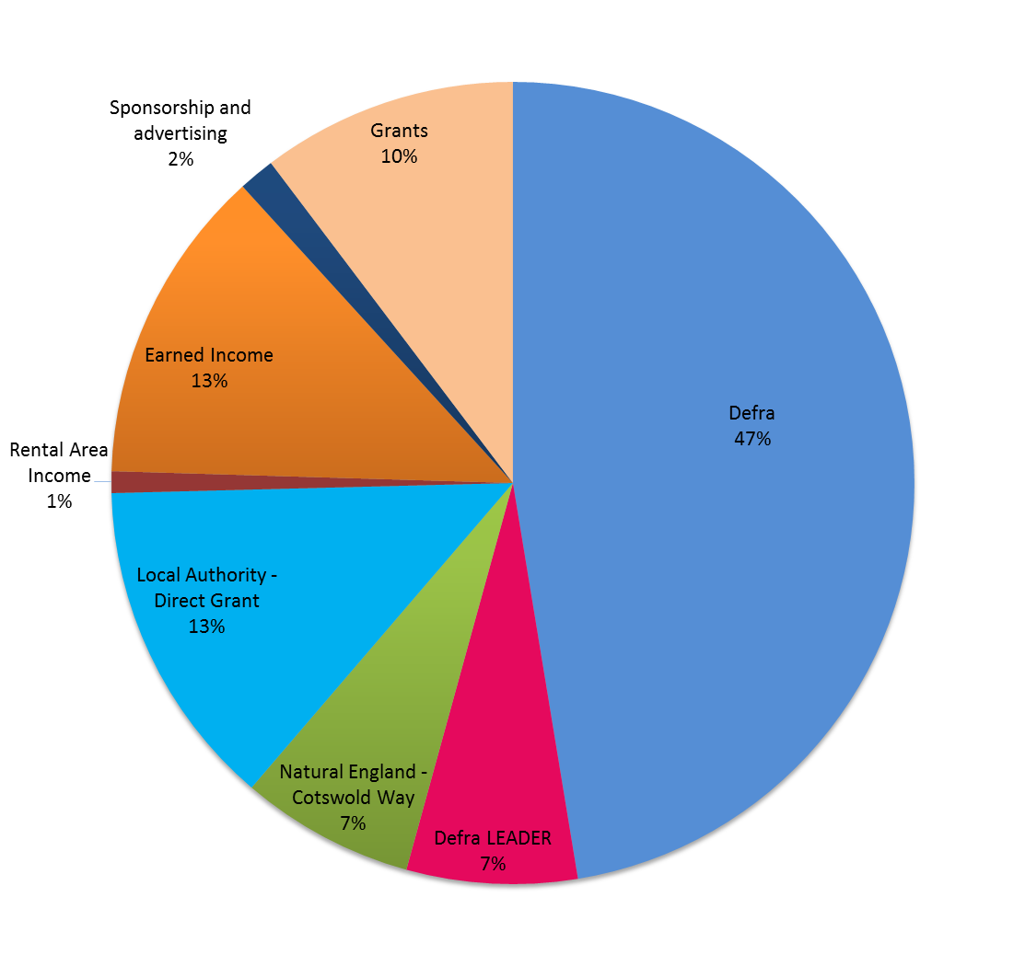

Earned income includes: rural skills course income, sales, advertising, donations including the Caring for the Cotswolds visitor giving scheme, and professional services/consultancy income

**Budgeted Expenditure by Statutory Purpose 2019/20**

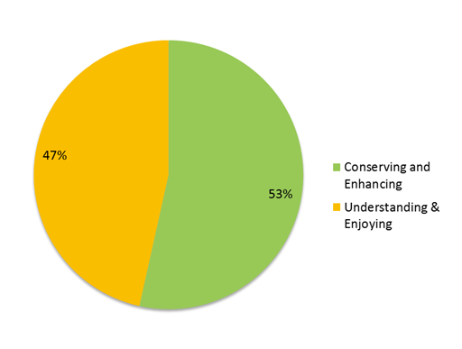

**Budgeted Expenditure 2019/20 by Management Plan Outcomes**

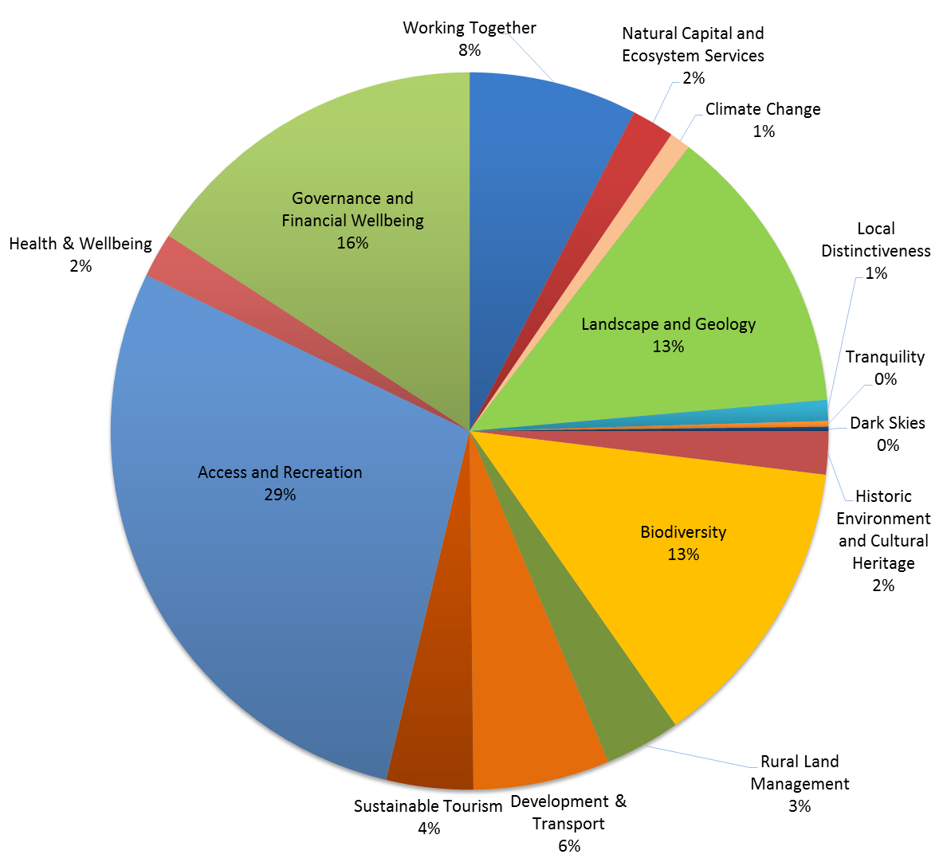

**Expenditure not included within the Budget**

The expenditure figures in the above pie charts only include the activities and projects the Board expects to fund. It does not include activity that will be delivered if planned bids are successful or the value of spend incurred by others with funding secured by the Board e.g. LEADER funds were secured and individual grants determined by a partnership led by the Board, but the grants are paid by the Rural Payments Agency . In 2017/18 the Board secured an overall investment of £2.1 million in the AONB.

Nor do the figures include the non-monetary value of the Board’s work, for example the voluntary wardens delivered over 47,000 hours of their time in 2017/18 equating to over £300,000 in financial terms.

In 2017/18 the Board turned every £1 invested by an individual local authority into £228 of investment in the AONB.

**Annex 1. Cotswolds AONB and the Cotswolds Conservation Board**

**Cotswolds Area of Outstanding Natural Beauty (AONB)**

The Cotswolds AONB was designated in 1966 to conserve and enhance the natural beauty of the area and in 2016 it celebrated its 50th anniversary. It is the largest of 38 Areas of Outstanding Natural Beauty in England and Wales, covering 790 sq miles (2038 sq kms). Of all the protected landscapes in England, only the Lake District and Yorkshire Dales National Parks are larger. The Cotswold Way National Trail runs along the western edge of the AONB.

A rich historical, cultural, and ecological mosaic, the Cotswolds is one of the country’s best known and most loved landscapes. The AONB is of equal landscape importance and value to that of a National Park. The area attracts an estimated 23 million visitors a year and is home to 150,000 people. It includes parts of 15 local authority areas and 283 town and parish councils and three regions.

**Cotswolds AONB Management Plan 2018-2023**

The Board formally adopted a statutory Cotswolds AONB Management Plan in September 2018 which runs until the end of March 2023.

The new Management Plan provides a vision and outcomes describing the desired state of the AONB. It also identifies the issues affecting the AONB and sets out the policies for addressing them.

The Management Plan is informed by and underpinned with evidence from the Cotswolds Landscape Character Assessment and Landscape Strategy and Guidelines. Policy within the Management Plan is expanded on through the publication of Position Statements. Its evidence base is further developed through the publication of reports such as the Farming, Forestry and Equestrian Sector report in 2015. Monitoring change across the AONB under the themes within the Management Plan is reported via a State of the Cotswolds report.

Engaging with the objectives and policies of the AONB Management Plan will help public bodies demonstrate compliance with their duty under Section 85 of the Countryside and Rights Of Way Act 2000 to “have regard to” the purposes of the designation of the AONB when carrying out their functions.

**The Board’s Business Planning**

This Business Plan provides a concise and costed description of what the Board intends to do to support the delivery of the AONB Management Plan. It is supported by a detailed work programme and budget. This plan’s place within the Board’s hierarchy of documents is illustrated below

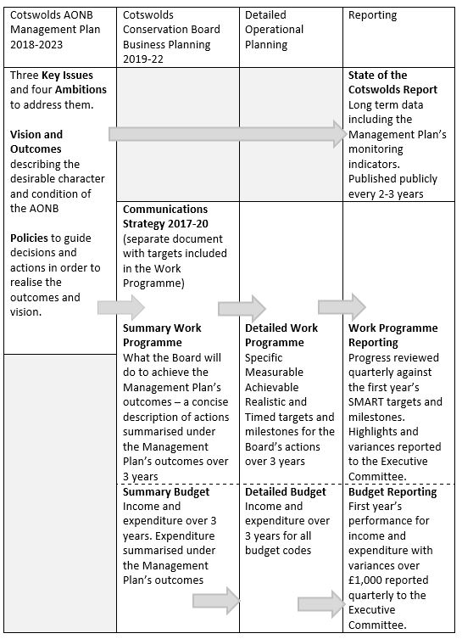

**The Board’s Way of Working**

In delivering our objectives the Board will;

1. Maintain a Board comprising of members offering a strong mix of private/commercial, public and NGO/voluntary sector skills supported by a well-respected and knowledgeable staff resource
2. Maintain the existing mix of advocacy, policy development, management plan publication, consultation responses and project delivery.
3. Develop a focus on innovation and new approaches to delivery and pass established projects and programmes to other deliverers where appropriate.
4. Work with the Friends of the Cotswolds to secure additional resources for the AONB; grants, sponsorships or philanthropic contributions to programmes of work and new initiatives.
5. Sustain a core public sector grant and seek greater delegation with associated income from the Defra group (Defra, Natural England, Environment Agency, Forestry Commission, Rural Payments Agency); e.g. project and programme delivery and responses to planning consultations, making better use of the Board’s policy and evidence base.
6. Deliver improved services e.g. public rights of way management in return for payments, working with the voluntary wardens to deliver a more cost effective and higher quality service whilst being seen to save the highway authorities money.
7. Take a strong commercial and income earning approach and deliver commercial consultancy services across the AONB. Develop a well-respected and acknowledged landscape, environmental, ecological, access, heritage and a specialised planning set of expertise (including a planning advisory service, advising at pre application and post consent stages).
8. Raise greater awareness of the fact that the Cotswolds AONB landscape is of the same quality and importance to that of the National Parks.
9. Advocate for a new single Protected Landscape Association

In doing so our geography will be the Cotswolds AONB and our purposes and remit will be that of a Conservation Board.

**Annex 2. Operating Context**

**Policy Context**

The Department for Environment, Food and Rural Affairs (Defra) and other government departments highlight the benefits to be derived from the natural world and the role of protected landscapes in delivering these benefits.

This concept is often summarised as ‘natural capital’. *Natural capital is our ‘stock’ of waters, land, air, species, minerals and oceans. This stock underpins our economy by producing value for people, both directly and indirectly. Goods provided by natural capital include clean air and water, food, energy, wildlife, recreation and protection from hazards.[3]*

'Cultural Capital' is the human counterpart of Natural Capital, embracing the imprint of past and present human interactions with the natural world on landscape and the evolution of society: it thus includes tangible and intangible heritage, as well as cultural activity.[4]

There is strong local evidence that the high quality of the environment underpins the local economy. An assessment of the economic value of the Cotswolds AONB published by the Board in 2013 estimated that the businesses critically dependent upon the high quality environment and landscape contributed £337 million a year to the local economy (Gross Value Added) and 9,720 jobs.

A number of key stakeholders have expressed enthusiasm for the idea of the Cotswolds becoming a National Park and the Board has agreed to promote the case for this change. Simultaneously the Government has established the Glover Review of England’s National Parks and AONBs. The Review is due to report in autumn 2019 and its recommendations will influence the future management of the Cotswolds and any decision as to whether National Park status is to be advanced.

The Board’s policy context will continue to develop rapidly throughout the life of this business plan. The result of the referendum to leave the European Union, the need for new homes and the policy response to the impacts of climate change as well as the mitigation goals determined through the 2015 United Nations Climate Change Conference, will all need continued consideration.

There is a plethora of policies and publications that the Board should arguably take note of but at this time three are particularly significant.

Defra’s 8 Point Plan for National Parks which has now been endorsed by the new Defra Secretary of State and Minister.

The Government’s “A Green Future: Our 25 Year Plan to Improve the Environment”, published in January 2018.

The Campaign to Protect Rural England (CPRE) report on housing in England’s AONB’s published in November 2017.

**Financial Context**

Defra have confirmed the financial settlement up until 2019/20, which provides for 1.7% inflation each year and is reflected in the budget section of this business plan.

This is clearly welcome although it comes with an expectation that new streams of revenue will be developed. The Board’s ways of working to deliver its purposes will continue to evolve in the light a challenging financial context.

1. See Annex 1
2. See Annex 2
3. Definition from the UK Natural Capital Committee
4. Manifesto for cultural Heritage in 2010.